How to use Stylelabs – Automated Local Dev Tasks Tool

1. Run Visual Studio as “Adminisrator”
2. Open solution “MLocalRun”
3. If you are using 64-bit operating system, please change to “x64” on the Solution Platforms dropdown and “x86” if you are using 32-bit operating system:



1. Run project
2. Git Connection:

* If you have an existing git repository on your local:

1. Check the textbox indicating you have an existing git repository
2. Browse the git repository folder

* If you don’t have an existing git repository on your local:

1. Choose the folder where the git repository will be cloned

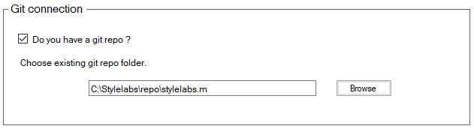

1. Git credentials:

* Select the branch that you want to checkout and provide your Bitbucket account (it will be redirected to the Bitbucket log-in page)

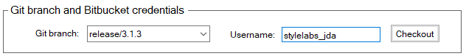

1. Click “Checkout” button to checkout the branch
2. Branch checkout details will be shown on the “Output” text area:

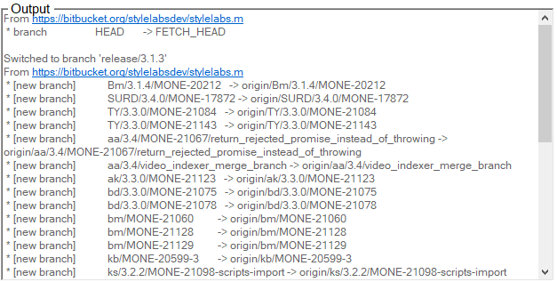

1. If you want to checkout a specific changeset, select the radio button to “Yes” and enter the changeset that you want to checkout:

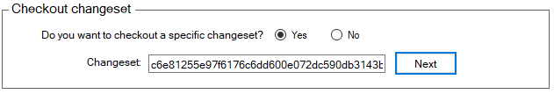

1. The Output text area will be cleared and updated with the latest checkout details of the changeset specified

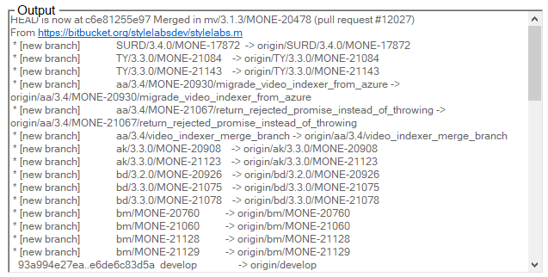

1. If the specified changeset is invalid, a message will be shown if how the user wants to proceed:

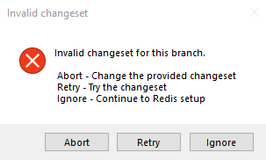

1. Redis setup

* Browse the path where the redis server is

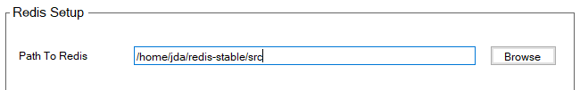

1. Select the dump .rdb file that you want to use:



and click “Next”

1. If the .rdb file is correct, it will be redirected to the “Redis and Elasticsearch” window:

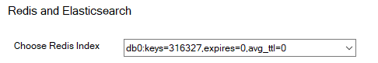

1. Browse the path of the elasticsearch:



and click “Submit”

1. If successful, the elasticsearch will start running:

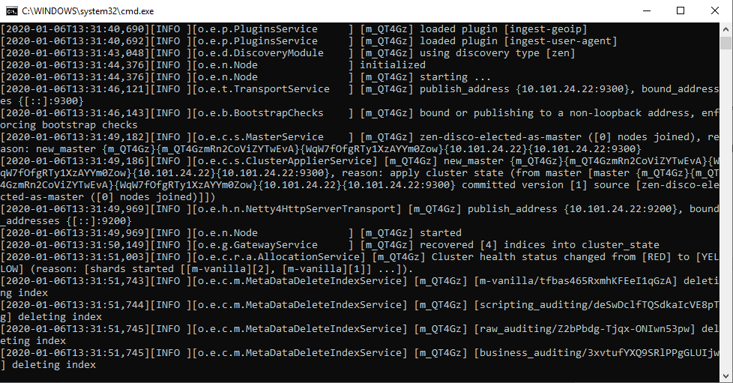

1. You will be asked if you want to save the new configurations that you provided:

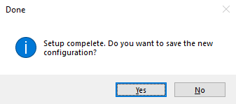

Note:

If you are done using this tool and you decide that you don’t want to use it, don’t forget to kill the task “redis-server” in task manager:

